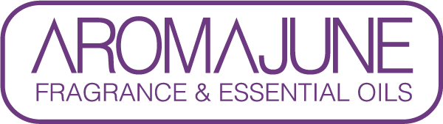

DATE : {{DATE}}
TO : {{CUSTOMER}}
SUBJECT : ANIMAL TEST & MATERIAL STATEMENT
PRODUCT NAME : {{PRODUCT}}

AROMAJUNE hereby states that the supplied fragrance does not contain any animal-derived ingredients or animal by-products. No animal-derived ingredients or by-products are used in the manufacturing process, and the product has not been tested on animals.



